Roll No: AM.EN.U4ECE22135 Date: 30/05/2025

Name: PAVITHRA A P

Amrita Vishwa Vidyapeetham, Amritapuri Campus

Department of Electronics and Communication Engineering

**19ECE384 / 19EAC386 Open lab-LabVIEW Programming (1-0-2-3)  
S6 B.Tech. ECE and EAC**

**Lab sheet 8 PAM – demodulation**

**Course Outcome mapping**

|  |  |  |
| --- | --- | --- |
| **CO1** | Ability to analyze practical problems and investigate scope for applying technology to develop feasible solutions | **Checkmark with solid fill** |
| **CO2** | Ability to review the state-of-the-art literature in the selected technology domain and arrive at functional solutions |  |
| **CO3** | Design the required system using appropriate EDA tools and implement the hardware |  |
| **CO4** | Ability to analyze the implementation impact and suggest improvements or modifications |  |
| **CO5** | Present the concept with adequate validation on technical aspects and cost analysis using a report and seminar |  |

1. PAM demodulation: Make a sub VI for demodulating the output of an AWGN, bandlimited, and attenuating channel carrying a PAM signal. Place level comparators so that the attenuated pulses can be converted back to the 2-bit binary sequence first, and then to a bit sequence. Plot the output eye diagram.

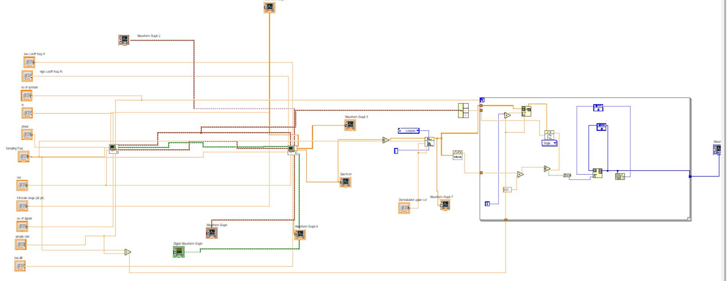

Front Panel:

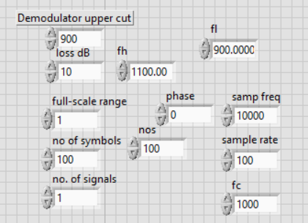

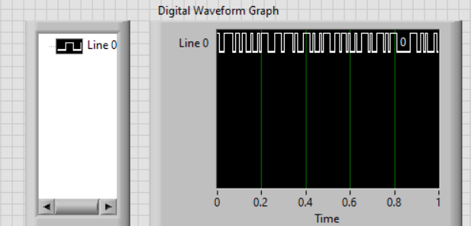

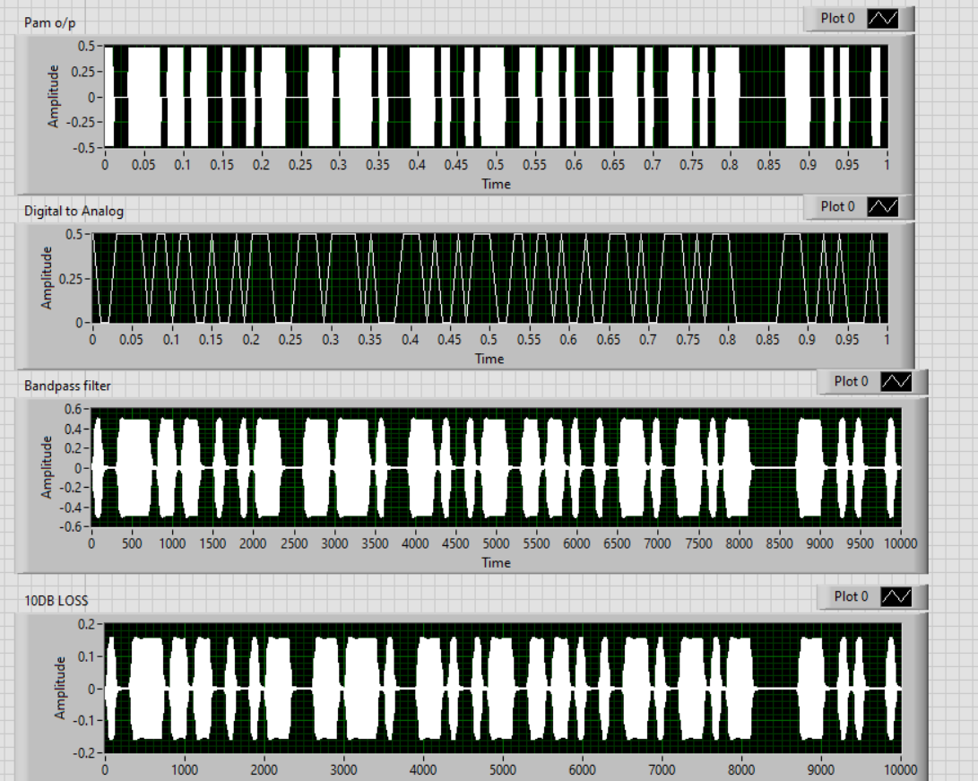

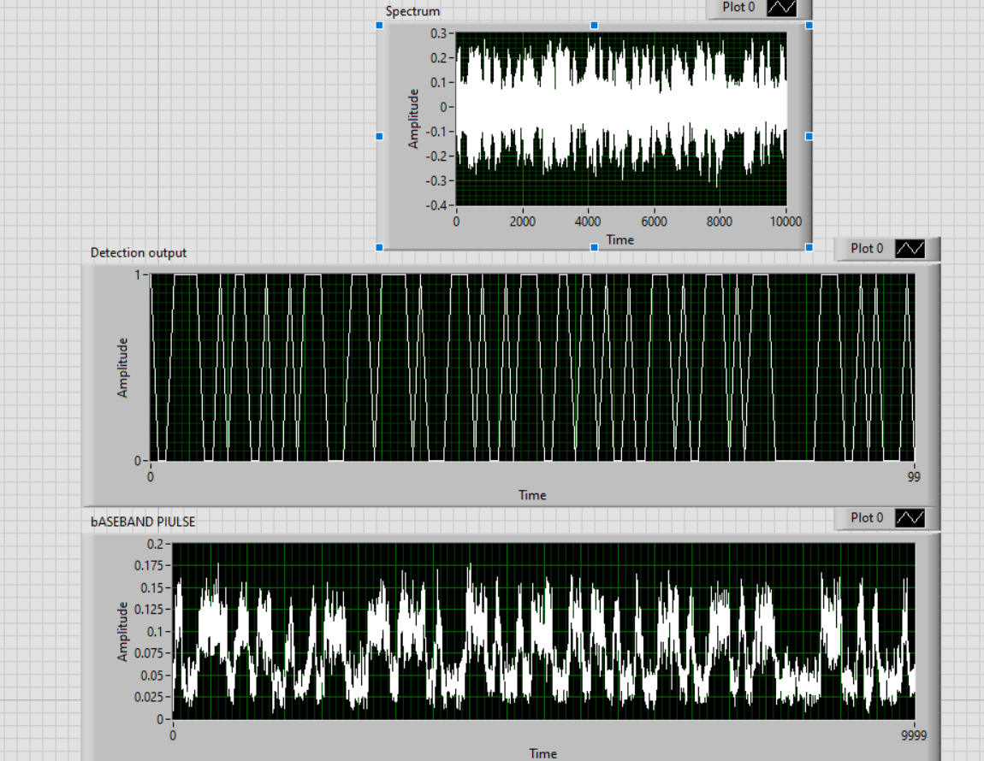

2. Comment on the effect of noise, attenuation, and band limited nature of the channel on the modulated signal.

1. **Noise (AWGN)**  
   Adds unpredictable variations to the PAM signal, making the amplitude levels less accurate. This uncertainty is particularly problematic around threshold levels, where it can lead to incorrect symbol or bit detection.
2. **Attenuation**  
   Decreases the strength of the PAM pulses, making the signal weaker. With reduced pulse amplitudes, it becomes more difficult for the system to clearly differentiate between signal levels, increasing the risk of decoding errors unless signal amplification is applied.
3. **Band-limited Channel**  
   Filters out the higher-frequency parts of the signal, which leads to the spreading of pulses over time. This results in overlap between adjacent pulses, known as inter-symbol interference (ISI), and produces distorted or "closed" eye diagrams that signal a decline in signal quality and clarity.

INFERENCE:

From the lab sheet, it was clearly observed that the quality of a PAM signal at the receiver end is significantly influenced by channel impairments such as noise, attenuation, and limited bandwidth. Additive white Gaussian noise introduces random fluctuations in the signal, which can push amplitude levels beyond their intended thresholds, causing incorrect symbol detection and bit errors. Attenuation reduces the overall amplitude of the PAM pulses, making it difficult for the level comparators to differentiate between closely spaced symbol levels, particularly in the absence of automatic gain control or amplification. Furthermore, a band-limited channel distorts the shape of the pulses by filtering out higher frequency components, resulting in inter-symbol interference (ISI), where adjacent symbols start to overlap, leading to decoding ambiguities. These effects are clearly visible in the eye diagram: a clean, wide-open eye suggests good signal integrity, while a closed or distorted eye indicates a degraded signal with higher likelihood of errors. Therefore, to ensure accurate demodulation, it is essential to design receiver systems that can mitigate these effects using equalization, filtering, or error-correction mechanisms. This experiment emphasizes the importance of understanding real-world channel behavior and designing robust communication systems to ensure reliable data recovery.